USAID Ghana identity

SUSTAINABLE FISHERIES MANAGEMENT PROJECT (SFMP)

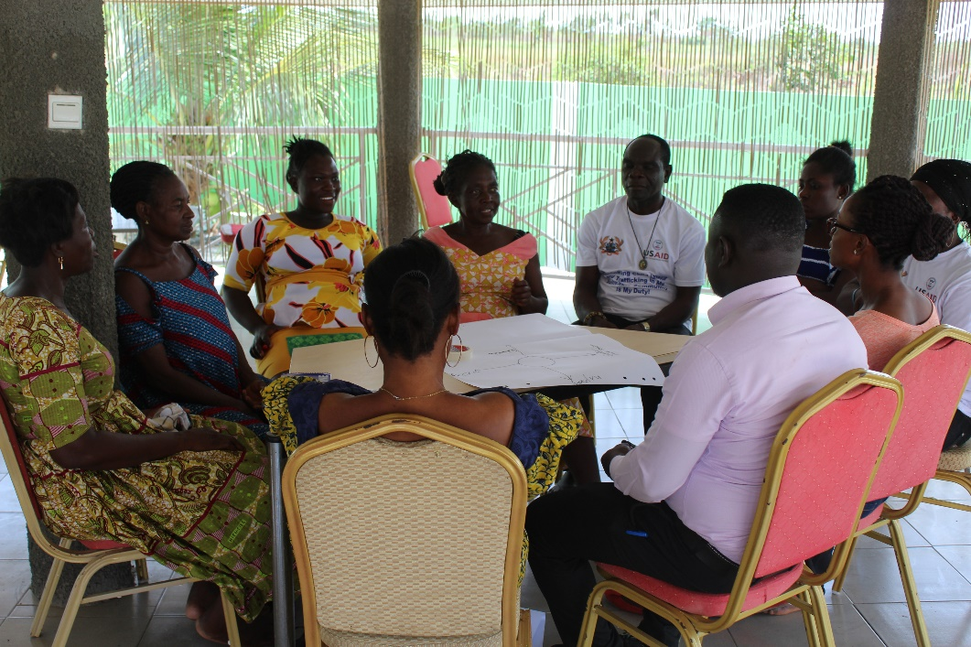Refresher Training For Community Anti-Clat Advocates

****APRIL, 2018

This publication is available electronically in the following locations:

*The Coastal Resources Center*

<http://www.crc.uri.edu/projects_page/ghanasfmp/>

*Ghanalinks.org*

<https://ghanalinks.org/elibrary> search term: SFMP

*USAID Development Clearing House*

<https://dec.usaid.gov/dec/content/search.aspx> search term: Ghana SFMP

**For more information** on the Ghana Sustainable Fisheries Management Project, contact:

USAID/Ghana Sustainable Fisheries Management Project

Coastal Resources Center

Graduate School of Oceanography

University of Rhode Island

220 South Ferry Rd.

Narragansett, RI 02882 USA

Tel: 401-874-6224 Fax: 401-874-6920 Email: [info@crc.uri.edu](mailto:info@crc.uri.edu)

**Citation**: Development Action Association. (2018). Refresher Training for Anti CLaT Advocates. The USAID/Ghana Sustainable Fisheries Management Project (SFMP). Narragansett, RI: Coastal Resources Center, Graduate School of Oceanography, University of Rhode Island GH2014_ACT203_DAA. 15 pp.

**Authority/Disclaimer:**

Prepared for USAID/Ghana under Cooperative Agreement (AID-641-A-15-00001), awarded on October 22, 2014 to the University of Rhode Island, and entitled the USAID/Ghana Sustainable Fisheries Management Project (SFMP).

This document is made possible by the support of the American People through the United States Agency for International Development (USAID). The views expressed and opinions contained in this report are those of the SFMP team and are not intended as statements of policy of either USAID or the cooperating organizations. As such, the contents of this report are the sole responsibility of the SFMP team and do not necessarily reflect the views of USAID or the United States Government.

**Cover photo**: A group session discussion causes of Child Labor and trafficking (Credit: Development Action Association)

**Detailed Partner Contact Information:**

**USAID/Ghana Sustainable Fisheries Management Project (SFMP)   
10 Obodai St., Mempeasem, East Legon, Accra, Ghana**

**Telephone: +233 0302 542497 Fax: +233 0302 542498**

Maurice Knight Chief of Party [maurice@crc.uri.edu](mailto:maurice@crc.uri.edu)

Kofi Agbogah Senior Fisheries Advisor [kagbogah@henmpoano.org](mailto:kagbogah@henmpoano.org)

Nii Odenkey Abbey Communications Officer [nii.sfmp@crcuri.org](mailto:nii.sfmp@crcuri.org)

Bakari Nyari Monitoring and Evaluation Specialist [hardinyari.sfmp@crcuri.org](mailto:hardinyari.sfmp@crcuri.org)

Brian Crawford Project Manager, CRC [brian@crc.uri.edu](mailto:brian@crc.uri.edu)

Ellis Ekekpi USAID AOR (acting) [eekekpi@usaid.gov](mailto:eekekpi@usaid.gov)

Kofi.Agbogah

[kagbogah@henmpoano.org](mailto:kagbogah@henmpoano.org)

Stephen Kankam

[skankam@henmpoano.org](mailto:skankam@henmpoano.org)

Hen Mpoano

38 J. Cross Cole St. Windy Ridge

Takoradi, Ghana

233 312 020 701

Andre de Jager

[adejager@snvworld.org](mailto:adejager@snvworld.org)

SNV Netherlands Development Organisation

#161, 10 Maseru Road,

E. Legon, Accra, Ghana

233 30 701 2440

Donkris Mevuta

Kyei Yamoah

[info@fonghana.org](mailto:info@fonghana.org)

Friends of the Nation

Parks and Gardens

Adiembra-Sekondi, Ghana

233 312 046 180

Resonance Global

(formerly SSG Advisors)

182 Main Street

Burlington, VT 05401

+1 (802) 735-1162

Thomas Buck

[tom@ssg-advisors.com](mailto:tom@ssg-advisors.com)

Victoria C. Koomson

[cewefia@gmail.com](mailto:cewefia@gmail.com)

CEWEFIA

B342 Bronyibima Estate

Elmina, Ghana

233 024 427 8377

Lydia Sasu

[daawomen@daawomen.org](mailto:daawomen@daawomen.org)

DAA

Darkuman Junction, Kaneshie Odokor Highway

Accra, Ghana

233 302 315894

**For additional information on partner activities:**

CRC/URI: <http://www.crc.uri.edu>

CEWEFIA: <http://cewefia.weebly.com/>

DAA: <http://womenthrive.org/development-action-association-daa>

Friends of the Nation: <http://www.fonghana.org>

Hen Mpoano: <http://www.henmpoano.org>

Resonance Global: <https://resonanceglobal.com/>

SNV: <http://www.snvworld.org/en/countries/ghana>

# ACRONYMS

GoG Government of Ghana

MDA Ministries, Departments and Agencies

CLaT Child labor and trafficking

SFMP Sustainable Fisheries Management Project

# TABLE OF CONTENTS

Contents

ACRONYMS iii

TABLE OF CONTENTS iv

LIST OF FIGURES v

SECTION 1: INTRODUCTION 1

1.1 Objectives of refresher training: 1

1.2 Ground Rules of Training 1

1.3 Training Expected 1

SECTION 2: TRAINING DELIVERY 2

2.1 Introduction to child Labor and trafficking 2

2.2 What type of work constitute child labor 3

2.3 Areas where children are involved 3

SECTION 3: COMMUNITY CHAMPION 3

3.1 Who is a Community champion? 3

3.2 Who Can Be a Community Champion? 3

3.3 Qualities That “Make” A Community Champion 4

3.4 Roles of Community Champions 4

SECTION 4: COMMUNICATION 4

4.1 Meaning of communication 4

4.2 Levels of Communication 5

4.3 Improving Listening Skills 5

SECTION 5: SYSTEMATIC REFERRAL MECHANISM AND PROTOCOLS 6

5.1 Identification and Screening Protocol 6

5.2 Guidelines for Interviewing Children 7

5.3 Referral Process 7

SECTION 6: RECOMMENDATIONS 8

SECTION 7: CONCLUSION 8

# LIST OF FIGURES

Figure 1. Children working in stone quarry 2

Figure 2. Children being trafficked 2

Figure 3. An advocate demonstrating levels of communication during the training 5

Figure 4. Facilitator Edem, training community advocates on identification and screening protocol 6

Figure 5. Mr. Emmanuel at Radio Windy Bay Winneba discussing on CLaT 8

Figure 6. Community Advocates after the refresher training pledging to say “child labor away in my Community" 9

# SECTION 1: INTRODUCTION

Child labor and trafficking has been on the forefront of social justice issues in the world for years, with poor countries in the most vulnerable and at-risk. An estimated 215 million children are reportedly engaged in several economic activities worldwide, and seventy percent (70%) of all child labor are found in agriculture (mainly fisheries and forestry)

The Sustainable Fisheries Project is funded by USAID with the objective of supporting the efforts of the Government of Ghana to rebuild marine fish stocks through the adoption of responsible fishing practices. SFMP’s intervention zones have over the years become sources and destinations for Child labor and Trafficking (CLaT). Children are of school going age are enslaved and exploited causing significant harm to them, their families and society.

To this end, SFMP has identified and trained some community members as champions to advocate for the prevention and of child labor and trafficking in their communities in the last 3 years.

A refresher training was held for these champions to reinvigorate and retool them with new skill for their advocacy. This was held at the Round House Guest House in Apam in April, 2018

## 1.1 Objectives of refresher training:

The objectives of the training are;

To refresh Community advocates on current development of child labor and trafficking in Ghana.

Help community champions to understand the current issues of child labor and trafficking.

Help in defining the roles, qualities and good practices of the community champion.

To develop community Advocates interpersonal skills to enable them communicate well with target households on CLaT issues.

## 1.2 Ground Rules of Training

The following ground rules were set by participants for the smooth running of the training:

All cell phones must put on silence to prevent distraction during training.

All participant must cooperate with facilitator for them to understand the lessons very well.

Any trainee who want recommend, suggest and ask question must do by signaling the facilitator with a raised hand.

there was also “class captain “who regulate movement and activities of participant that will interfere with training.

## 1.3 Training Expected

The participants expressed their expectation from the training as;

To be equipped with good communication skills as a community advocate.

To obtain new knowledge on child labor and trafficking.

To understand negative impacts of child labor and trafficking to be able to advocate better.

To really understand the work of volunteer advocate.

# SECTION 2: TRAINING DELIVERY

## 2.1 Introduction to child Labor and trafficking

The facilitator defined child labor as when a child is subjected to any work that interferes with compulsory schooling and is mentally, physically, socially or morally dangerous and harmful to the child. While child trafficking is when a child is moved from his comfort zone for exploitation.

Participants were made to understand that, Child Labor and Trafficking (CLaT) deprives children of their basic rights and opportunities to free compulsory basic education. Such as seen in the pictures below;

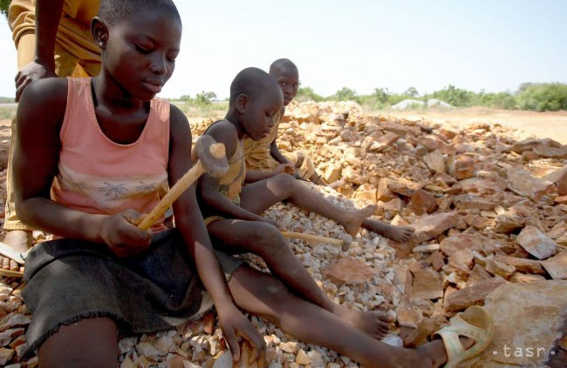

Figure . Children working in stone quarry

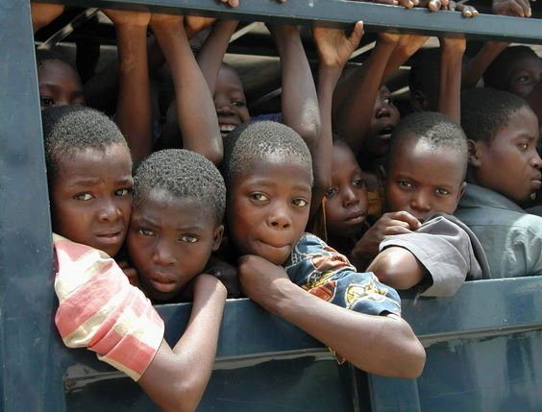

Figure . Children being trafficked

## 2.2 What type of work constitute child labor

According to the facilitator, the type, hours of work and the conditions under which the work is performed is determined by the age of the child. However, work which is likely to harm the health, safety or morals of the child institute child labor. Participants were taken through examples of work that does not constitute child labor. Any work that does not affect children's health and personal development or interfere with their schooling is generally regarded as chores, e.g. helping parents around the home, assisting in a family business or earning pocket money outside school hours and during school holidays.

## 2.3 Areas where children are involved

The facilitator asked the community champions to mention the type of work usually done by children in their communities. They mentioned;

Net making

Boat building

Work on board vessels

Unloading catches

Preparing nets and baits

Fish in aquaculture ponds

Selling of Fish

Sorting of fish

Feeding and harvesting

Processing of fish

Stone quarry

Child prostitution

# SECTION 3: COMMUNITY CHAMPION

## 3.1 Who is a Community champion?

The facilitator defined a Community champion, as a person who makes a positive difference by helping others. They are real people, men and women of all ages and backgrounds who have the time, commitment and skills to understand local community issues and to utilize their skills, knowledge and resources to make a difference.

## 3.2 Who Can Be a Community Champion?

According to the facilitator individuals, community minded groups and/or institutions can be community champions when they develop an interest in emerging problem in their society and are willing to help solve them. He asked the trainees to mention people who can be champions in their communities. To this, they mentioned;

Seniors, Teens and Adults

Educators

Healthcare workers

Nursing homes

Service and social clubs

Professional associations

Youth organizations

School groups

Individual Educators

Community

Schools

Local authorities

Religious bodies

Fisher men

Fish processers

Local charities

## 3.3 Qualities That “Make” A Community Champion

The facilitator led the participants to discuss the qualities required of a community advocate/champion. Some of the qualities identified are as follows;

Be passionate about issues in the community.

What am I passionate about? What charitable passions lie within?

What social issues can I support, commit to and invest my time, talent and resources?

A community champion seeks out organizations that match his/her core values of giving and takes action to give back.

A community champion garners support from family, friends, employees and employers to broaden his/her network and provide greater support to his/her charitable passion.

A community champion ensures that the provision of good work is celebrated in a humble yet visible way so others may learn firsthand of the joys of giving back to the community and encourage others to do same.

## 3.4 Roles of Community Champions

Every community advocate has a specific role to play for the development of the community. The facilitator outlined some roles expected of a community champion/advocates as;

Meeting local charities and services to find out how we can help them.

Supporting local charities and services to raise their profile within the community.

Supporting local fundraising events with raffle prizes and refreshments.

Meeting the religious bodies to create awareness on CLaT issues.

Gather stories of interest on CLaTs and identify CLaTS victims in the community.

Forming clubs in schools to create awareness on CLaTs.

Encouraging parents to send their children to school because it is their human right.

Referring CLaT issues to the Department of Social Welfare.

# SECTION 4: COMMUNICATION

## 4.1 Meaning of communication

According to the facilitator, communication is a dynamic process through which we convey a thought or feeling to someone else. How it is received depends on a set of events and the stimuli that a person is exposed to.

How you say what you say plays an important role in communication.

Communication is a series of experiences of;

Hearing

Smelling

Seeing

Touching

Tasting

Community advocates were made to understand that, how they communicate in the society may impact on their work. Since child labor and trafficking is a sensitive issue in our community, advocates must have good communication skills to handle such issues. Based on this, advocates should possess good “hearing, smelling, seeing and tasting” skills to make their work effective.

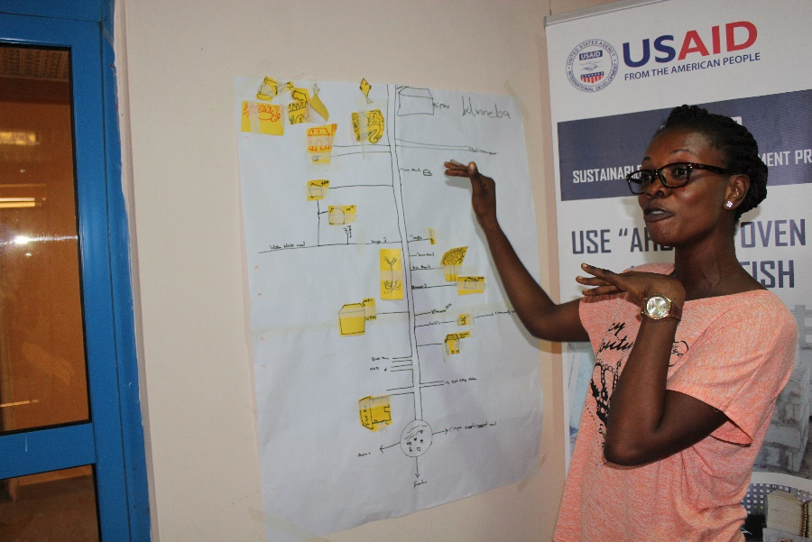

Figure . An advocate demonstrating levels of communication during the training

## 4.2 Levels of Communication

The facilitator educated the participants on various communication levels they can adopt to enhance their advocacy work. Some of these are;

Verbal

Intra verbal: intonation of word and sound.

Extra verbal: implication of words and phrases, semantics.

Non-Verbal

Gestures

Postures

## 4.3 Improving Listening Skills

The facilitator admonished the advocates to develop good listening skills as it is essential to their role. According to him “A good communicator is good listener”. He asked the advocates to observe the following attributes to improve on the communication skills”

Do not be Preoccupied.

Being Open Minded & Non-Defensive.

Minimizing Interruptions.

Effective Listening is: Hearing, interpreting when necessary, understanding the message and relating to it.

By Asking Questions.

# SECTION 5: SYSTEMATIC REFERRAL MECHANISM AND PROTOCOLS

## 5.1 Identification and Screening Protocol

The participants were educated on the appropriate protocols for identifying and screening trafficked children. According to the facilitator, human trafficking constitutes a serious infringement of one’s rights. Identifying trafficked persons is vital to ensuring victims are granted access to comprehensive protection and support services.

Identification requires determining the status of a person as a victim of trafficking, and screening is the process by which trained social service workers learn more about the victims of trafficking, their medium and long-term needs.

If a victim is not identified as such, he or she could be left without appropriate support in order to recover from the trafficking ordeal and this is to the detriment of the trafficked victim. A vital first step to providing victim protection, therefore, is determining whether an individual is in fact a victim of human trafficking. Furthermore, without access to protection and support services, trafficked persons might not have sufficient confidence and security to co-operate with law enforcement officials in criminal investigations. Without evidence and testimony from trafficked persons, it is difficult to prosecute traffickers

A victim can provide critical information to social service workers or law enforcement officials used for purposes of protection, prevention, and prosecution. To successfully cooperate with a victim, it is important to recognize their basic human rights, including the right information, confidentiality, protection, and non-discrimination. If the victim is a child, authorities, parents, next friends, and guardians must act in the best interest of the child and respect the views of the child.

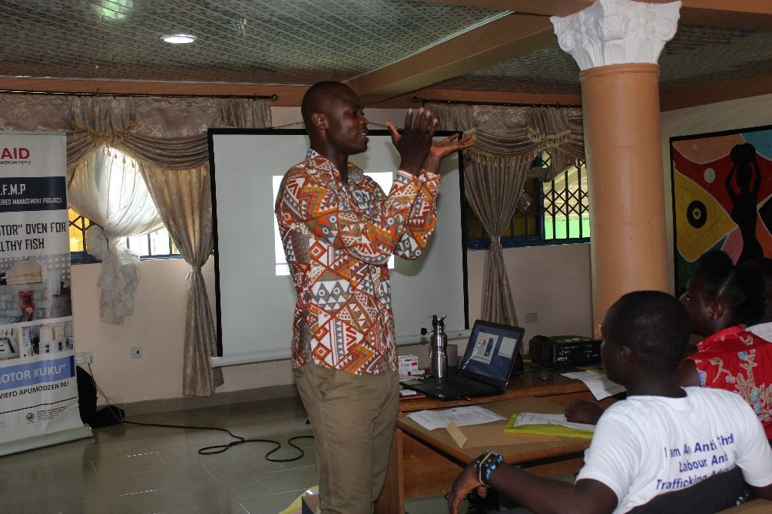

Figure . Facilitator Edem, training community advocates on identification and screening protocol

## 5.2 Guidelines for Interviewing Children

The facilitator intimated that, interviewing children require special guidelines, as their young minds do not usually understand their situation. Obtaining useful information from them therefore demands the following considerations;

Create an interview space that is age appropriate, possibly containing toys, books, or games. This may not always be possible due to resource constraints, but due efforts must be made.

Sit at eye-level with the child, smile, and speak gently. Greet the child and introduce yourself, your role and what the interview is about.

Establish rapport by talking about, or doing things that are not related to the trafficking experience (discuss things the child is familiar with).

Keep the atmosphere simple and informal.

Use mother-tongue and child-friendly language.

Explain things in a manner that the child can understand. Questions should be adapted to the age and mental capacity of the child.

Begin with open-ended questions, allowing the child to give their own account. Avoid leading questions.

Do not pursue and press for details where there are signs that the child has told everything that they know. Keep in mind that children may leave information out, or may give an answer that they believe the interviewer wishes to hear.

Interviews with children should take place in the presence of a parent, guardian.

## 5.3 Referral Process

On the appropriate referral process, the facilitator intimated that given the diverse needs and considerations when identifying and screening a child victim of trafficking, it is critical to have effective referral procedures to ensure timely assistance. The aim of establishing referral procedures during the identification and screening process is to encourage cooperation and coordination between stakeholders at all levels of operation: community, district, region, and national. It is also to allow actors to fulfil their obligation to protect and promote the human rights of child victims of trafficking. The basic aim is to ensure children are effectively identified, rescued, and interviewed in victim-centred and child-friendly manner through the harmonized efforts of all relevant stakeholders.

Child trafficking is a complex and complicated issue. To approach the issue holistically, many national stakeholders must take simultaneous and coordinated action. The Government of Ghana, specifically the Human Trafficking Secretariat within the MGCSP, leads in the overall coordination of government and non-governmental organizations with relation to identification and screening policy and protocol. In addition, there are several key ministries, departments, and agencies (MDAs) within the GoG with important roles and functions when identifying and screening child victims of trafficking. Participants were notified about importance of referral process and were shown places of where they refer victims of child labour and trafficking to in their communities.

# SECTION 6: RECOMMENDATIONS

After the training participants recommended key actions to implement and collaborate for progress as advocacy in the communities.

Below is some recommendation from the training:

Formation of a common communication platform using WhatsApp.

It’s also recommended that such trainings should be organized in their communities.

In the Advocates again, recommended that, for their active participation in activities organized at their communities like video shows, radio discussion and focus group discussion, they should be given prior notices to enable them plan very for the programs.

# SECTION 7: CONCLUSION

The refresher training for community Anti-CLaT advocates came to successful end. All the participants took a pledge to fight against child labour and trafficking in their communities. They took a pledged that: “child labour and trafficking away in my community. We know what to do, and we know how to do it. The means are at hand, it is up to us to seize the opportunity and build a world that is fit for children.”

The refresher training, built capacities of the advocates, this was demonstrated when a day after the training two advocates from Apam and Winneba, joined were invited for a radio discussion at Radio Windy Bay to sensitize the public on child labor and trafficking at Winneba.



Figure . Mr. Emmanuel at Radio Windy Bay Winneba discussing on CLaT

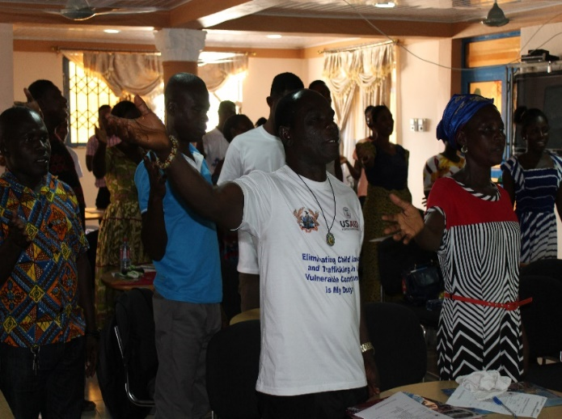

Figure . Community Advocates after the refresher training pledging to say “child labor away in my Community"